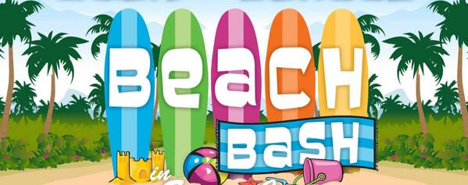

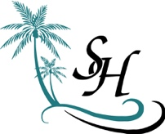 **Homeowners Beach Bash**

**May 17, 2025 6:00pm  
In the Homeowners Lounge**

**BYOBeverage & A Dish to Share**

**Sunday May 18th 11:00am In the Homeowners Lounge  
Join Your Neighbors for A Bakery & Coffee Brunch**

**__________________________________________**

**Reminder -** Annual Meeting at The Embassy Suites  
Vintage 12 Room (By Coastal Grill Restaurant) 1:30pm

Questions: Lynn 440-668-1515